Room Booking - User Guide
This guide employs Outlook Web App (OWA) as an example to book a room. Similar steps apply to Outlook 2010 and Outlook 2007.
- Logon to Outlook Web App (OWA) with your ITSC Network Account.
https://owa.exchange.ust.hk/
- On the toolbar menu, click the arrow next to New, and then click Meeting Request.
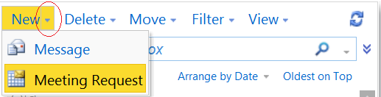
- Click Resources…, then All Rooms. Double click your desired Room (assume you have the required access right to book the room) and the Room will be put under
“Resources ->” as show in the example below. Click OK to continue.
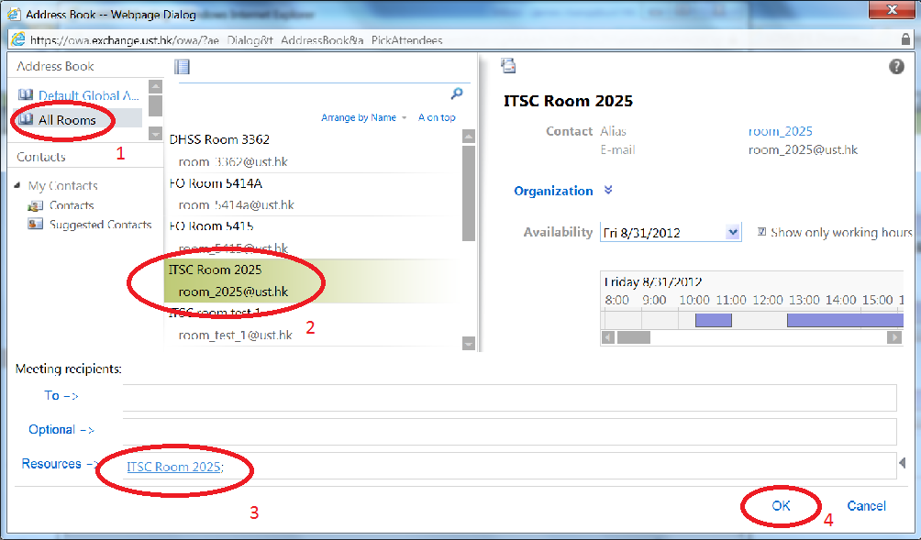
- In the Subject box, type a description e.g. Meeting with Vendor
- In the Start time and End time lists, select the appropriate dates and times.
- Optional - Click the Scheduling Assistant tab to double check the availability of the conference room. The free/busy grid shows the availability. A green vertical line represents the start of the meeting. A red vertical line represents the end of the meeting. Make sure it is not occupied as shown if the picture below. Adjust your schedule if is not. You may also make use the Suggested Times as well.
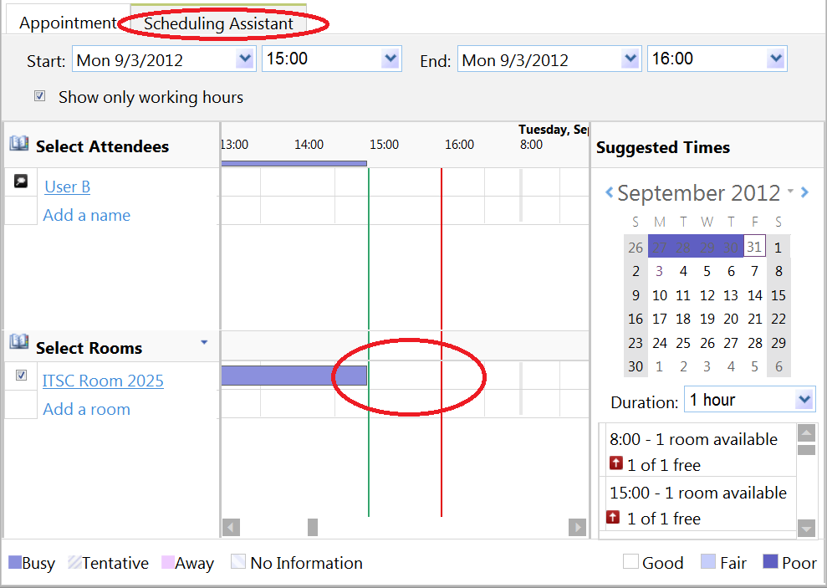
- Click Send or press ALT+S. The booking request is sent and the new meeting is added to your Calendar.
- You will receive an email message from the Room Resource e.g. “ITSC Room 2025” that your request has been accepted.
To cancel the meeting, right click the entry in your own Calendar and select “Delete”. Click Send when prompted to cancel the meeting.

Appendix – Subscribe a Room Calendar
You may check the availability of a room by subscribe to its calendar. If you have the required privilege, you can view the details of the bookings. Please note that the subscribed room calendar has “Read-Only” permission.
To subscribe a Room Calendar:
- Logon to Outlook Web App (OWA) with your ITSC Network Account from
  - https://owa.exchange.ust.hk/
- Click Calendar on the lower left Navigation pane.
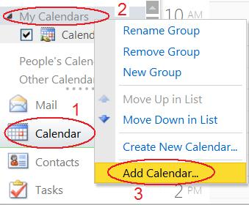
- Right click My Calendar and then select Add Calendar…
- Click Names… under the option “Calendar from your organization”.
- Click All Rooms.
- Double click your desired room and then click OK.
- Click OK to close the “Add Calendar” window.
- You can view entries in the Room calendar and view the booking details by hover your mouse pointer above each of the entry.
- You may also click the expansion icon to view more appointments if you are in the Month view. Close the “appointments” view by pressing the “Esc” button.
